ABSTRACT

Mass media sources, specifically the news media, have traditionally informed us of daily events. In modern times, social media services such as Twitter provide an enormous amount of user-generated data, which have great potential to contain informative news-related content. For these resources to be useful, we must find a way to filter noise and only capture the content that, based on its similarity to the news media, is considered valuable. However, even after noise is removed, information overload may still exist in the remaining data; it is convenient to prioritize it for consumption. To achieve prioritization, information must be ranked in order of estimated importance considering three factors. First, the temporal prevalence of a particular topic in the news media is a factor of importance, and can be considered the media focus (MF) of a topic. Second, the temporal prevalence of the topic in social media indicates its user attention (UA). Last, the interaction between the social media users who mention this topic indicates the strength of the community discussing it, and can be regarded as the user interaction (UI) toward the topic. We propose an unsupervised framework—SociRank—which identifies news topics prevalent in both social media and the news media, and then ranks them by relevance using their degrees of MF, UA, and UI. Our experiments show that SociRank improves the quality and variety of automatically identified news topics.

Index Terms—Big Data; Access Control; Privacy-preserving Policy; Attribute Bloom Filter; LSSS Access Structure
.

1. INTRODUCTION
1.1 INTRODUCTION:

The mining of valuable information from online sources has become a prominent research area in information technology in recent years. Historically, knowledge that apprises the general public of daily events has been provided by mass media sources, specifically the news media. Many of these news media sources have either abandoned their hardcopy publications and moved to the World Wide Web, or now produce both hard-copy and Internet versions simultaneously. These news media sources are considered reliable because they are published by professional journalists, who are held accountable for their content. On the other hand, the Internet, being a free and open forum for information exchange, has recently seen a fascinating phenomenon known as social media. In social media, regular, nonjournalist users are able to publish unverified content and express their interest in certain events. Microblogs have become one of the most popular social media outlets. One microblogging service in particular, Twitter, is used by millions of people around the world, providing enormous amounts of user-generated data. One may assume that this source potentially contains information with equal or greater value than the news media, but one must also assume that because of the unverified nature of the source, much of this content is useless. For social media data to be of any use for topic identification, we must find a way to filter uninformative information and capture only information which, based on its content similarity to the news media, may be considered useful or valuable.
The news media presents professionally verified occurrences or events, while social media presents the interests of the audience in these areas, and may thus provide insight into their popularity. Social media services like Twitter can also provide additional or supporting information to a particular news media topic. In summary, truly valuable information may be thought of as the area in which these two media sources topically intersect. Unfortunately, even after the removal of unimportant content, there is still information overload in the remaining news-related data, which must be prioritized for consumption.
To assist in the prioritization of news information, news must be ranked in order of estimated importance. The temporal prevalence of a particular topic in the news media indicates that it is widely covered by news media sources, making it an important factor when estimating topical relevance. This factor may be referred to as the MF of the topic. The temporal prevalence of the topic in social media, specifically in Twitter, indicates that users are interested in the topic and can provide a basis for the estimation of its popularity. This factor is regarded as the UA of the topic. Likewise, the number of users discussing a topic and the interaction between them also gives insight into topical importance, referred to as the UI. By combining these three factors, we gain insight into topical importance and are then able to rank the news topics accordingly.

Consolidated, filtered, and ranked news topics from both professional news providers and individuals have several benefits. The most evident use is the potential to improve the quality and coverage of news recommender systems or Web feeds, adding user popularity feedback. Additionally, news topics that perhaps were not perceived as popular by the mass media could be uncovered from social media and given more coverage and priority. For instance, a particular story that has been discontinued by news providers could be given resurgence and continued if it is still a popular topic among social networks. This information, in turn, can be filtered to discover how particular topics are discussed in different geographic locations, which serve as feedback for businesses and governments.
A straightforward approach for identifying topics from different social and news media sources is the application of topic modeling. Many methods have been proposed in this area, such as latent Dirichlet allocation (LDA) [1] and probabilistic latent semantic analysis (PLSA) [2], [3]. Topic modeling is, in essence, the discovery of “topics” in text corpora by clustering together frequently co-occurring words This approach, however, misses out in the temporal component of prevalent topic detection, that is, it does not take into account how topics change with time. Furthermore, topic modeling and other topic detection techniques do notrank topics according to their popularity by taking into account their prevalence in both news media and social media.

We propose an unsupervised system—SocialRank—which effectively identifies news topics that are prevalent in both social media and the news media, and then ranks them by relevance using their degrees of MF, UA, and UI. Even though this paper focuses on news topics, it can be easily adapted to a wide variety of fields, from science and technology to culture and sports. To the best of our knowledge, no other work attempts to employ the use of either the social media interests of users or their social relationships to aid in the ranking of topics. Moreover, SocialRank undergoes an empirical framework, comprising and integrating several techniques, such as keyword extraction, measures of similarity, graph clustering, and social network analysis. The effectiveness of our system is validated by extensive controlled and uncontrolled experiments.

To achieve its goal, SocialRank uses keywords from news media sources (for a specified period of time) to identify the overlap with social media from that same period. We then build a graph whose nodes represent these keywords and whose edges depict their co-occurrences in social media. The graph is then clustered to clearly identify distinct topics. After obtaining well-separated topic clusters (TCs), the factors that signify their importance are calculated: MF, UA, and UI. Finally, the topics are ranked by an overall measure that combines these three factors.
.

2. LITERATURE SURVEY

Probabilistic latent semantic analysis

Consistency and completeness of biomolecular annotations is a keypoint of correct interpretation of biological experiments. Yet, the associations between genes (or proteins) and features correctly annotated are just some of all the existing ones. As time goes by, they increase in number and become more useful, but they remain incomplete and some of them incorrect. To support and quicken their time-consuming curation procedure and to improve consistence of available annotations, computational methods that are able to supply a ranked list of predicted annotations are hence extremely useful. Starting from a previous work on the automatic prediction of Gene Ontology (GO) annotations based on the Singular Value Decomposition of the annotation matrix, where every matrix element corresponds to the association of a gene with a feature, we propose the use of a modified Probabilistic Latent Semantic Analysis (pLSA) algorithm, named pLSAnorm, to better perform such prediction. pLSA is a statistical technique from the natural language processing field, which has not been used in bioinformatics annotation prediction yet; it takes advantage of the latent information contained in the analyzed data co-occurrences. We proved the effectiveness of the pLSAnorm prediction method by performing k-fold cross-validation of the GO annotations of two organisms, Gallus gallus and Bos taurus. Obtained results demonstrate the efficacy of our approach.

Topic detection by clustering keywords

We consider topic detection without any prior knowledgeof category structure or possible categories. Keywords are extracted and clustered based on different similarity measures using the induced k-bisecting clustering algorithm. Evaluation on Wikipedia articles shows that clusters of keywords correlate strongly with the Wikipedia categories of the articles. In addition, we find that a distance measure based on the Jensen-Shannon divergence of probability distributions outperforms the cosine similarity. In particular, a newly proposed term distribution taking co-occurrence of terms into account gives best results.

A hierarchical document clustering environment based on the induced bisecting k-means

The steady increase of information on WWW, digital library, portal, database and local intranet, gave rise to the development of several methods to help user in Information Retrieval, information organization and browsing. Clustering algorithms are of crucial importance when there are no labels associated to textual information or documents. The aim of clustering algorithms, in the text mining domain, is to group documents concerning with the same topic into the same cluster, producing a flat or hierarchical structure of clusters. In this paper we present a Knowledge Discovery System for document processing and clustering. The clustering algorithm implemented in this system, called Induced Bisecting k-Means, outperforms the Standard Bisecting k-Means and is particularly suitable for on line applications when computational efficiency is a crucial aspect.

Emerging topic detection on twitter based on temporal and social terms evaluation

Twitter is a user-generated content system that allows its users to share short text messages, called tweets, for a variety of purposes, including daily conversations, URLs sharing and information news. Considering its world-wide distributed network of users of any age and social condition, it represents a low level news flashes portal that, in its impressive short response time, has the principal advantage.

In this paper we recognize this primary role of Twitter and we propose a novel topic detection technique that permits to retrieve in real-time the most emergent topics expressed by the community. First, we extract the contents (set of terms) of the tweets and model the term life cycle according to a novel aging theory intended to mine the emerging ones. A term can be defined as emerging if it frequently occurs in the specified time interval and it was relatively rare in the past. Moreover, considering that the importance of a content also depends on its source, we analyze the social relationships in the network with the well-known Page Rank algorithm in order to determine the authority of the users. Finally, we leverage a navigable topic graph which connects the emerging terms with other semantically related keywords, allowing the detection of the emerging topics, under user-specified time constraints. We provide different case studies which show the validity of the proposed approach.

Comparing twitter and traditional media using topic models
Twitter as a new form of social media can potentially contain much useful information, but content analysis on Twitter has not been well studied. In particular, it is not clear whether as an information source Twitter can be simply regarded as a faster news feed that covers mostly the same information as traditional news media. In This paper we empirically compare the content of Twitter with a traditional news medium, New York Times, using unsupervised topic modeling. We use a Twitter-LDA model to discover topics from a representative sample of the entire Twitter. We then use text mining techniques to compare these Twitter topics with topics from New York Times, taking into consideration topic categories and types. We also study the relation between the proportions of opinionated tweets and retweets and topic categories and types. Our comparisons show interesting and useful findings for downstream IR or DM applications.
finding bursty topics from microblogs

Microblogs such as Twitter reflect the general public's reactions to major events. Bursty topics from microblogs reveal what events have attracted the most online attention. Although bursty event detection from text streams has been studied before, previous work may not be suitable for microblogs because compared with other text streams such as news articles and scientific publications, microblog posts are particularly diverse and noisy. To find topics that have bursty patterns on microblogs, we propose a topic model that simultaneously captures two observations: (1) posts published around the same time are more likely to have the same topic, and (2) posts published by the same user are more likely to have the same topic. The former helps find event-driven posts while the latter helps identify and filter out "personal" posts. Our experiments on a large Twitter dataset show that there are more meaningful and unique bursty topics in the top-ranked results returned by our model than an LDA baseline and two degenerate variations of our model. We also show some case studies that demonstrate the importance of considering both the temporal information and users' personal interests for bursty topic detection from microblogs.

A unified model for stable and temporal topic detection from social media data

Web 2.0 users generate and spread huge amounts of messages in online social media. Such user-generated contents are mixture of temporal topics (e.g., breaking events) and stable topics (e.g., user interests). Due to their different natures, it is important and useful to distinguish temporal topics from stable topics in social media. However, such discrimination is very challenging because the user-generated texts in social media are very short in length and thus lack useful linguistic features for precise analysis using traditional approaches. In this paper, we propose a novel solution to detect both stable and temporal topics simultaneously from social media data. Specifically, a unified user-temporal mixture model is proposed to distinguish temporal topics from stable topics. To improve this model's performance, we design a regularization framework that exploits prior spatial information in a social network, as well as a burst-weighted smoothing scheme that exploits temporal prior information in the time dimension. We conduct extensive experiments to evaluate our proposal on two real data sets obtained from Del.icio.us and Twitter. The experimental results verify that our mixture model is able to distinguish temporal topics from stable topics in a single detection process. Our mixture model enhanced with the spatial regularization and the burst-weighted smoothing scheme significantly outperforms competitor approaches, in terms of topic detection accuracy and discrimination in stable and temporal topics.

3. SYSTEM ANALYSIS

3.1 EXISTING SYSTEM

- Wartena and Brussee [4] implemented a method to detect topics by clustering keywords. Their method entails the clustering of keywords—based on different similarity measures—using the induced k-bisecting clustering algorithm. Although they do not employ the use of graphs, they do observe that a distance measure based on the Jensen–Shannon divergence (or information radius) of probability distributions performs well.

- More recently, research has been conducted in identifying topics and events from social media data, taking into account temporal information. Cataldi et al. [7] proposed a topic detection technique that retrieves real-time emerging topics from Twitter. Their methods uses the set of terms from tweets and model their life cycle according to a novel aging theory.

- Additionally, they take into account social relationships—more specifically, the authority of the users in the network—to determine the importance of the topics. Zhao et al. [8] carried out similar work by developing a Twitter-LDA model designed to identify topics in tweets. Their work, however, only considers the personal interests of users, and not prevalent topics at a global scale.

3.2 DISADVANTAGES

  - There is no Information filtering for social computing.
  - There is anonymous topic ranking.

3.3 PROPOSED SYSTEM

- In the proposed system, the method proposed an unsupervised method— SociRank—which identifies news topics prevalent in both social media and the news media, and then ranks them by taking into account their MF, UA, and UI as relevance factors.

- The temporal prevalence of a particular topic in the news media is considered the MF of a topic, which gives us insight into its mass media popularity. The temporal prevalence of the topic in social media, specifically Twitter, indicates user interest, and is considered its UA.

- Finally, the interaction between the social media users who mention the topic indicates the strength of the community discussing it, and is considered the UI. To the best of our knowledge, no other work has attempted to employ the use of either the interests of social media users or their social relationships to aid in the ranking of topics.

3.4 ADVANTAGES

- There is effective Topic Identification and keyword extraction.
- Efficient Outlier Detection

3.5 IMPLEMENTATION

Modules
- Admin
In this module, the Admin has to login by using valid user name and password. After login successful he can perform some operations such as Authorizing users, Login ,View all users and authorize, give click option to view all users locations in GMap using Multiple Markers ,View all Friend Request and Response ,View all users time line tweet details with Soci rank, rating and give tweet ,View all tweets by clustering based on tweet name and show tweeted details, Soci_Rank, rating and View all Relevant Term Identification on all tweets and group together(similar tweeted details for each and every created tweet) ,View all users outlier detection tweet with its tweeted details, Soci_Rank, rating and View all term frequency on all tweets count(Display the tweets which is getting tweet regularly ) based on tweet name, View all tweet news Socirank in chart and View all tweet term frequency count in chart based on date and time, View all tweets tweeted socirank in chart

Friend Request & Response

In this module, the admin can view all the friend requests and responses. Here all the requests and responses will be displayed with their tags such as Id, requested user photo, requested user name, user name request to, status and time & date. If the user accepts the request then the status will be changed to accept or else the status will remains as waiting.

- User
In this module, there are n numbers of users are present. User should register before performing any operations. Once user registers, their details will be stored to the database. After registration successful, he has to login by using authorized user name and password. Once Login is successful user can perform some operations like Register with Location with lat and login using GMap and Login, View Your Profile with location ,Search Friend and Find Friend Request, View all Your Friends Details and Location Route path from Your Location, View all your time line tweets with Soci rank, rating and give tweet, Create tweet for News like Tweet name, tweet uses, Tweet desc (enc),tweet image and View all your tweet with re tweet details, Socirank, rating, Search tweet and list all Tweets and view its details and give re tweet, give rank by hyper link and View all your friends Tweets and give Tweet

Searching Users to make friends

In this module, the user searches for users in Same Site and in the Sites and sends friend requests to them. The user can search for users in other sites to make friends only if they have permission.

.

4. SOFTWARE REQUIREMENT SPECIFICATION

4.1 REQUIREMENTS SPECIFICATION:

Requirement Specification provides a high secure storage to the web server efficiently. Software requirements deal with software and hardware resources that need to be installed on a serve which provides optimal functioning for the application. These software and hardware requirements need to be installed before the packages are installed. These are the most common set of requirements defined by any operation system. These software and hardware requirements provide a compatible support to the operation system in developing an application.

4.1.1 HARDWARE REQUIREMENTS:

The hardware requirement specifies each interface of the software elements and the hardware elements of the system. These hardware requirements include configuration characteristics.

System : Pentium IV 2.4 GHz.

Hard Disk : 100 GB.

Monitor : 15 VGA Color.

Mouse : Logitech.

RAM : 1 GB.

4.1.2 SOFTWARE REQUIREMENTS:

The software requirements specify the use of all required software products like data management system. The required software product specifies the numbers and version. Each interface specifies the purpose of the interfacing software as related to this software product.

Operating system : Windows XP/7/10
- Coding Language : Html, JavaScript, Java/J2EE (Jsp Servlet)
- Development Kit : JDK 1.7
- Database : MySQL
- IDE : Netbeans
- Server : Tomcat 7.0

4.1.3 FUNCTIONAL REQUIREMENTS:
The functional requirement refers to the system needs in an exceedingly computer code engineering method.
The key goal of determinant “functional requirements” in an exceedingly product style and implementation is to capture the desired behavior of a software package in terms of practicality and also the technology implementation of the business processes.

4.1.4 NON FUNCTIONAL REQUIREMENTS
All the other requirements which do not form a part of the above specification are categorized as Non-Functional needs. A system perhaps needed to gift the user with a show of the quantity of records during a info. If the quantity must be updated in real time, the system architects should make sure that the system is capable of change the displayed record count at intervals associate tolerably short interval of the quantity of records dynamic. Comfortable network information measure may additionally be a non-functional requirement of a system.
The following are the features:
- Accessibility
- Availability
- Backup
- Certification
- Compliance
- Configuration Management
- Documentation
- Disaster Recovery
- Efficiency(resource consumption for given load)
- Interoperability

4.2 FEASIBILITY STUDY
In this phase the projects feasibility is estimated and a business proposal is prepared with basic plan for the project involving the cost involved in realizing the project. During the phase of system analysis the feasibility study of the project will be thoroughly analyzed so that in future the company will not face burden due to proposed system.
One needs to understand the important requirements for the system during feasibility analysis. The main considerations during feasibility analysis are as follows:
- FINANCIAL FEASIBILITY
- TECHNICAL FEASIBILITY
- SOCIAL FEASIBILITY
4.2.1 FINANCIAL FEASIBILITY

The main aim of carrying this study is to evaluate the financial impact an organization will have by taking up this project. Here the funds required for research and development of the proposed system is limited. The entire expenses must be justified. Hence the system is developed well within the allocated budget because many technologies we used are available cheaply. We had only purchased the customized products.
All the existing system’s data flow and procedures to be followed will be taken care by present computerized system and it will also generate entire reports of the manual system including management reports.
The project should be developed as a web based application which has separate data base server and web server. This is essential because all the activities are scattered across the organization and the customer needs a centralized database.
Further few linked transactions will take place in various locations. This includes the proposed projects feasibility to generate additional economic benefits. There is a need for cost benefit analysis (comparing the problem solving technique in proposed project to other approaches for the same problem in various projects). A breakeven analysis is a necessity during evaluating the financial details of project (fixed and variable costs and utilization/sales forecasts will be addressed).
In order to facilitate a consistent basis for evaluation all the tangible and intangible aspects of a project must be translated into economic terms.

4.2.2 TECHNICAL FEASIBILITY

In order to evaluate all the technical requirements of the system technical feasibility is carried out. When a system is developed it should not have high demand for present technical resources. Because of this the client should face the high demands from the developer. The system to be developed must only have modest needs and which can be implemented with minimal or no changes. The main problems raised during technical feasibility study are as follows:
- Whether there is necessary technology to realize what is suggested in the project.
- Do the suggested equipments have the technical capabilities to process the data needed by the new system.
- Regardless of the number or location of users does the proposed system give adequate response to inquiries?
- Possibility for the system to be upgraded if developed?
- Whether there are necessary technical guarantees of accuracy, ease of access, reliability, and data security
During assessing the technical feasibility a major part of determining resources will take place. In this analysis one must find whether the present technical resources if upgraded or with few add-ons in a proper manner will satisfy the requests under consideration. However in some cases the add-ons to the existing system will be costly and nonrealistic because they may not meet required needs efficiently.
When there is no possibility for the existing system to take add-ons the next step is to find whether there is suitable technology to meet the required specifications. Here comes the importance of the system analysis and its benefits. With their experience and vendor contacts they will answer these questions of technical feasibility. In most of the cases the answer to whether there is certain technology available which is capable to meet users request is ‘YES’ but then the financials involved should be considered.

4.2.3 SOCIAL FEASIBILITY

Social feasibility study evaluates the user acceptance of the proposed system. This process involves proper training of the user in order to efficiently use the system. The system should not threaten the user with its complexity but should make him realize it is a necessity.
The user acceptance of the system will depend on different methods that are employed to make the user familiar with the system by educating them. Because the client is the final user of the system his constructive criticism should be accepted and this will only happen when his confidence in the system is raised.
The impact of the proposed project on social system in the project environment will be addressed in social feasibility. For the proposed technology there may be a shortfall or non-existent of skilled workers. To ensure compatibility the influence of the project on the social status of the project participants should be assessed.
One should accept the fact that workers will have specific status symbol in the society in relation to the field they are working. For example any infrastructure project will have certain social and environmental impacts due to construction operations. The impact can be both positive and negative depending upon the point of evaluation.
Due to few projects some communities will have social impact, for example Infrastructure projects needs resettlement and the associated impact will be on quality of life and livelihood and because of environmental alteration health and livelihood of workers will effect.

4.3 JAVA

4.3.1 Java Technology
Java technology is used both as a programming language and as a platform.
The Java Programming Language
Java programming language can be described as a high-level language which can be represented by all of the following buzzwords:
How this works is illustrated below:

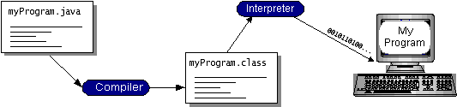

Figure 4.3.1 Figure depicting Java Virtual Machine Interactions

We could acknowledge that for java Virtual machine (java VM) java byte codes similarly as the machine code guidelines. Java mediator Previously, Possibly advancement device or on a web program which runs applets may be only a execution of java VM. “Write once, run anywhere” could be allowed with the assistance about java byte codes. On any stage that need and java compiler; we can gather our project under byte codes.
We can run on any execution of the java VM utilizing those created byte codes. This intends until there will be java VM on the machine those same project which is coded clinched alongside java modifying dialect might be run on Windows 2000, a Solaris workstation, or with respect to a iMac.

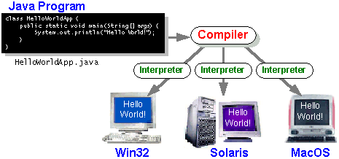
Figure 4.3.2 Java Platform
The Java Platform
In place with run a project we require specific fittings or product which will be termed as stage. Windows 2000, Solaris, Linux, and MacOS are couple of great referred to platforms. A stage could make portrayed similarly as an consolidation from claiming both working framework and fittings. Java can't be clubbed with those over specified platforms in light java is software-only stage which runs on highest priority on other platforms which would In view of specific fittings.
The two components of Java platform are:
- Java VM
- Java API
We had basal addition of Java VM which is the abject for Java belvedere and is acquainted to altered hardware-based platforms. Graphical user interface (GUI) widgets and accumulation of abounding readymade software apparatus will be accessible in Java API. These software apparatus are classified into libraries of accompanying classes and interfaces. We appellation these libraries as packages.

In the abutting chapter, what will Java technology do? Describes the functions provided by some of Java API packages. The amount illustrates a affairs which is active on the Java platform. We can acutely accomplish out that both the Java API and the Java basic apparatus insulates the affairs from the hardware.

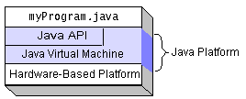

Figure 4.3.3 JDK Architecture
Though the aggregated code runs ahead a particular fittings stage then afterward we gather the code it may be called as local code which will be An touch speedier. However on java stage constantly An platform-independent nature's domain java will be An spot moderate over local code. We might accomplish execution close to to that of local code without bargaining on portability Toward well-tuned interpreters.
Performance of Java
Utilizing java modifying dialect we compose as a relatable point projects, for example, applets Also provisions. You quit offering on that one who surfs web, applets will be well referred to. Applet might make depicted Concerning illustration An project which stays with specific tenets in-order to permit it will run inside java enabled program.
Furthermore composing code for enthralling applets to web which would simple, high-keyed java modifying dialect may be likewise utilized to composing capable product with incredulous functionalities.
A significant number sorts about projects could a chance to be composed utilizing java API.
We could characterize a requisition Similarly as an free system which will straightforwardly run on java stage. In there are customers to An system an extraordinary provision known as server backs them. Few cases for servers need aid Web servers, proxy servers, mail servers, Also print servers. Further there is a servlet which is comparable with applet Anyway runs on server side. To building intelligent web provisions Furthermore swapping the utilization from claiming CGI scripts java Servlets are generally utilized.
Servlets need aid barely like the applets in which they are runtime extensions of provisions. Here Servlets run inside java Web servers configuring or customizing those server. API backs large portions sorts for projects for bundles about product segments that the table broad range of functionalities.

4.3.2 NETBEANS IDE

Netbeans is a open source project dedicated to providing rock solid computer code development merchandise that address the wants of developers, users and therefore the businesses WHO have faith in Netbeans as a basis for his or her products; significantly, to alter them to develop these merchandise quickly, expeditiously and simply by investing the strengths of the Java platform and alternative relevant business standards.

The Netbeans project is additionally a vivacious community within which folks from across the world will raise queries, offer recommendation, contribute and ultimately share within the success of our merchandise. On the NetBeans mailing lists and forums, you'll realize posts from students, developers from prime firms, and people trying to expand their skills.
The IDE is meant to limit secret writing errors and facilitate error correction with tools like the NetBeansFindBugs to find and fix common Java secret writing issues and computer program to manage advanced code with field watches, breakpoints and execution watching. though the NetBeans IDE is meant specifically for Java developers, it additionally supports C/C++, PHP, Groovy, and HTML5 additionally to Java, JavaScript and JavaFX.

4.3.3 JAVASCRIPT

JavaScript mainly used for Client side scripting for validations. The usage of JavaScript tags below:
<SCRIPTS>..</SCRIPT>.
<SCRIPT LANGUAGE = “JavaScript”>
A JavaScript basic statement goes here.
</SCRIPT>

4.3.4 HYPER TEXT MARKUP LANGUAGE

HTML mainly used to develop WebPages, It is very simple to learn and develop with the help of javascript, css.

Basic HTML Tags:
<!-- --> Commenting system
<A>……….</A> Provides URL Links called hyperlinks
<B>……….</B> Text will looks Bold
<BIG>……….</BIG> Visible text in Big Size.
<BODY>…</BODY> Main body of the web page
<CENTER>...</CENTER> Where our web page text appears middle.
<DL>...</DL> Provides definition list
<FONT>…</FONT> we can keep our text with particular font.
<FRAME>...</FRAME> uses a specific frame in a number of frames
<H#>…</H#> Headings starts from H1 to H6
<HEAD>...</HEAD> Main aim goes here
<HR>...</HR> Horizontal Line appears Here.
<HTML>…</HTML> This is starting and ending tag for whole page.
<META>...</META> Meta includes style sheets, meta keywords, meta description, etc.
<SCRIPT>…</SCRIPT> Contains java script, php, asp, etc scripting languages
<TABLE>…</TABLE> Creates a table with number of rows and columns
<TD>…</TD> provides table data in a table
<TR>…</TR> Designates a table row
<TH>…</TH> Creates a heading in a table

4.4 BACK END

4.4.1 JDBC

With that point of setting-up, an autonomous database standard API for Java; Java Database Connectivity was created by Sun Microsystems or JDBC. JDBC gives a ceaseless interface to various sorts of RDBMSs with the assistance of a nonspecific SQL database get to the system. This nonstop interface is conceivable with the utilization of "module" database network modules, or drivers. Database merchant must give the driver to every stage that the database and Java keep running on in the event that he or she wishes to have JDBC bolster.

With a specific end goal to have a more prominent acknowledgment of JDBC, Sun constructs JDBC's system in light of ODBC. We are natural that ODBC will have a huge help on various kinds of stages. By planning JDBC on ODBC will assist sellers to carry JDBC drivers with marketing more sooner than building up an absolutely new network arrangement.

JDBC was first declared in March 1996 and was discharged for an open survey for a time of 90 which finished on June 8, 1996. With the assistance of client input, the last JDBC v1.0 detail was promptly discharged.

The rest of the segment will give fundamental data about JDBC. Keeping in mind the end goal to recognize what it is and how successfully we can utilize it. This ought not to be considered as a total review of JDBC in light of the fact that the points of interest of JDBC alone will fill a whole book.

4.4.2 JDBC Goals

Activity charts would graphical portrayals of the worth of effort techniques for stepwise work out what's more exercises with help to the decision, emphasis, and Also synchronization. In the bound together demonstrating Language, activity layouts might a chance to be used will depict that business Also operational great requested worth of effort forms from claiming segments clinched alongside a skeleton. A development graph exhibits the general stream of control:

1. SQL Level API
2. SQL Conformance
3. Keep it simple
4. Use strong
5. Keep the common cases simple
6. JDBC should be instrumental on high of common info interfaces
7. Providing Java interface

1. SQL Level API

The essential objective of the originators was to characterize a SQL interface for Java. Despite the fact that it isn't the most reduced database interface conceivable, SQL interface level is at a sufficiently low to create more elevated amount instruments and APIs. In addition application developers can utilize SQL interface unhesitatingly at a larger amount programming. By accomplishing this objective it opens the entryway for future device sellers to "produce" JDBC code and with this the merchant can conceal numerous complexities of JDBC from the end client.

2. SQL Conformance

At the point when database merchant changes SQL punctuation differs individually. For supporting a wide assortment of sellers, any question articulation to be gone through it to the required database driver will be permitted by JDBC. According to the client prerequisites, the non-standard functionalities can be taken care of with the assistance of network module.

Usage of JDBC must be over normal database interfaces

Continuously the JDBC SQL API must "sit" over other essential SQL level APIs. This objective acknowledges JDBC to apply show ODBC level drivers by utilizing a product interface. This interface will change over/make an interpretation of JDBC calls to ODBC and the other way around.

A steady Java interface with the rest of the Java framework ought to be given

The originator's trust they ought not to veer off from the present plan of center Java framework because of Java's acknowledgment in the client group.

- Keep it simple

While developing this project a simple and efficient software design is proposed. JDBC plays important role in establishing communication between front end and backend. In order to work application effectively as simple one method execution design for JDBC without any multiple query execution with duplicate functionality.

4. Use strong, static typing wherever possible
Basic issues like typing and error checking issues must be clear because at time of compiling this will be issue and time wasting process.

5. Keep the common cases simple
As we are using sql query concept in this application .Sql statements used in this application are simple which will cover only SELECT, INSTER, DELETE AND UPDATE features. When we use these statements in programming JDBC must able to execute query in short time at the same time it should support complete Queries.
6. JDBC must be implemental on top of common database interfaces
In this project JDBC is used for communication with database so we use API but we also need ODBC driver which will work as low level support for JDBC. We use interface to communicate between JDBC and ODBC and vice versa.
7. Providing Java interface
With the comfort features that are provided by java platform developer of this application feels using same core java system will be helpful with current design. Developer decided to implement project in java platform because it supports networking concepts and easy updating data to database with cache table MS access is suitable database. Java woks as programming oriented and platform oriented.
Java provides a high level support in terms of debugging and compiling. We can easily compile and interpret data. While compiling data java compiler will translate java code in to machine level language which is called java bytes code which is a platform independent and these machine level code is communicated with computer.
Difference between compilation and interpretation is explained here. In compilation code is converted in machine language which is done only once but interpretation occurs every time when code is executed which is explained in diagram.
After compiling java code byte codes are in the form of machine level coding which are like instructions for Java virtual machine in short called as JVM. Whereas java interpreter is useful for running any type of web applications or network related application and supports applets which are part of tool package. Java virtual machine also supports hardware implementation.
Java provides compatibility, if java code is compiled in one system and generates byte code that code can be run on any operating system like Windows NT, UNIX, Linux, Solaris.etc. But these systems should have java compiler.

5. SYSTEM DESIGN

5.1 SYSTEM ARCHITECTURE

The purpose of the design phase is to arrange an answer of the matter such as by the necessity document. This part is that the opening moves in moving the matter domain to the answer domain. The design phase satisfies the requirements of the system. The design of a system is probably the foremost crucial issue warm heartedness the standard of the software package. It’s a serious impact on the later part, notably testing and maintenance.

The output of this part is that the style of the document. This document is analogous to a blueprint of answer and is employed later throughout implementation, testing and maintenance. The design activity is commonly divided into 2 separate phases System Design and Detailed Design.

System Design conjointly referred to as top-ranking style aims to spot the modules that ought to be within the system, the specifications of those modules, and the way them move with one another to supply the specified results.

At the top of the system style all the main knowledge structures, file formats, output formats, and also the major modules within the system and their specifications square measure set. System design is that the method or art of process the design, components, modules, interfaces, and knowledge for a system to satisfy such as needs. Users will read it because the application of systems theory to development.

Detailed Design, the inner logic of every of the modules laid out in system design is determined. Throughout this part, the small print of the info of a module square measure sometimes laid out in a high-level style description language that is freelance of the target language within which the software package can eventually be enforced.

In system design the main target is on distinguishing the modules, whereas throughout careful style the main target is on planning the logic for every of the modules.

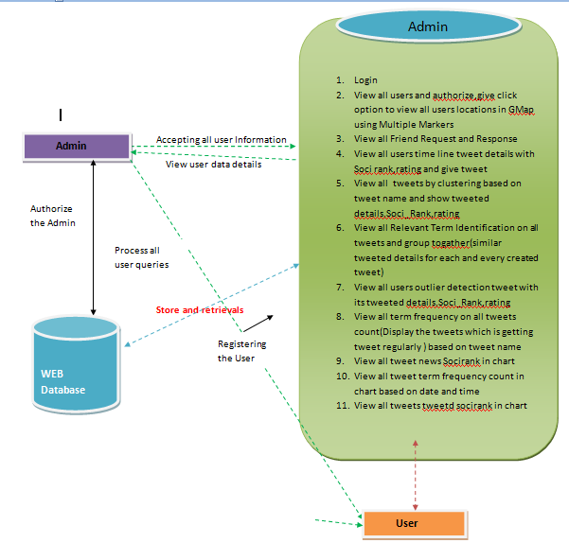

Figure 5.1: Architecture diagram

5.2 DATA FLOW DIAGRAMS

Data Flow Diagram can also be termed as bubble chart. It is a pictorial or graphical form, which can be applied to represent the input data to a system and multiple functions carried out on the data and the generated output by the system.

A graphical tool accustomed describe and analyze the instant of knowledge through a system manual or automatic together with the method, stores of knowledge, and delays within the system. The transformation of knowledge from input to output, through processes, is also delineate logically and severally of the physical elements related to the system. The DFD is also known as a data flow graph or a bubble chart.The BasicNotation used to create a DFD’s are as follows:
- Dataflow:

- Process:
.


- Source:

- Data Store:
 


- Rhombus: decision

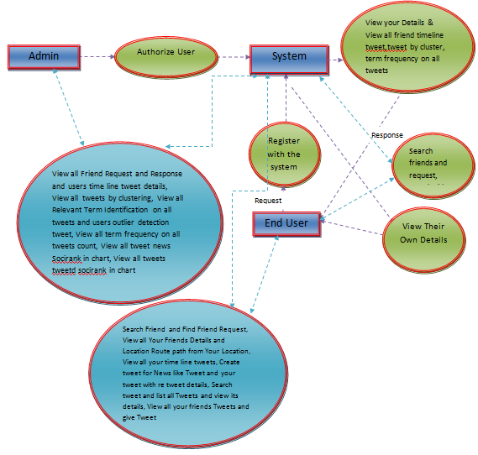

Figure 5.2: Data Flow diagram

5.3 UML DIAGRAMS
UML remains for Unified Modeling Language. UML is an institutionalized broadly useful displaying dialect in the field of protest situated programming designing. The standard is overseen, and was made by, the Object Management Group.
The objective is for UML to wind up noticeably a typical dialect for making models of question arranged PC programming. In its present shape UML is contained two noteworthy segments: a Meta-show and documentation. Later on, some type of technique or process may likewise be added to; or connected with, UML.
The Unified Modeling Language is a standard dialect for determining, Visualization, Constructing and recording the relics of programming framework, and also for business demonstrating and other non-programming frameworks.
The UML speaks to a gathering of best designing practices that have demonstrated fruitful in the displaying of huge and complex frameworks. The UML is an essential piece of creating items arranged programming and the product improvement handle. The UML utilizes generally graphical documentations to express the plan of programming activities.
GOALS:
The Primary objectives in the outline of the UML are as per the following:
1. Provide clients a prepared to-utilize, expressive visual demonstrating Language with the goal that they can create and trade important models.
2. Provide extendibility and specialization components to broaden the center ideas.
3. be autonomous of specific programming dialects and improvement prepare.
4. Provide a formal reason for understanding the demonstrating dialect.
5. Encourage the development of OO apparatuses showcase.
6. Support larger amount advancement ideas, for example, coordinated efforts, structures, examples and parts.
7. Integrate accepted procedures
5.3.1 USE CASE DIAGRAM
A use case outline in the Unified Modeling Language (UML) is a sort of behavioral diagram portrayed by and produced using a Use-case examination. Its inspiration is to show a graphical diagram of the helpfulness given by a structure similarly as on-screen characters, their targets (addressed as use cases), and any conditions between those usage cases. The essential inspiration driving a usage case diagram is to show what system limits are performed for which on-screen character. Parts of the on-screen characters in the structure can be depicted.

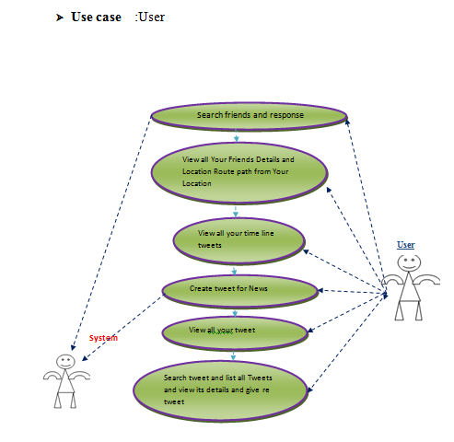
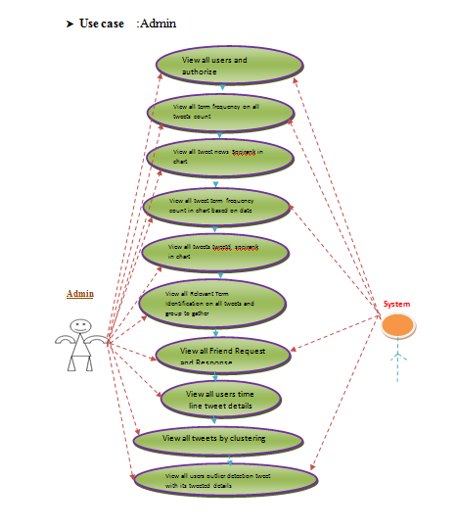
Figure 5.3.1 Use Case Diagram

    - CLASS DIAGRAM

In programming building, a class chart in the Unified Modeling Language (UML) is a sort of static structure graph that portrays the structure of a framework by demonstrating the framework's classes, their qualities, operations (or strategies), and the connections among the classes. It clarifies which class contains information.

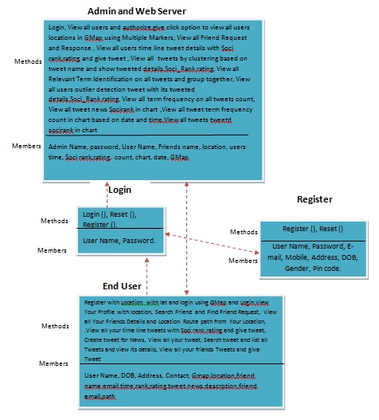
Figure 5.3.2: Class Diagram

5.3.3 SEQUENCEDIAGRAM

A succession graph in Unified Modeling Language (UML) is a sort of cooperation chart that shows how forms work with each other and in what arrange. It is a developed one of a Message Sequence Chart. Arrangement outlines are at times called occasion graphs, occasion situations, and timing charts.

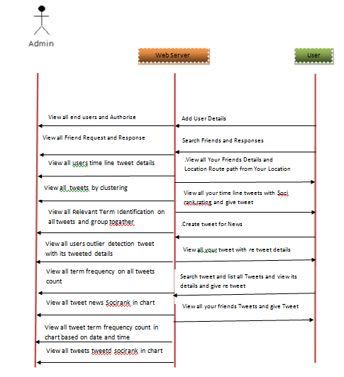

Figure 5.3.3: Sequence diagram

5.3.4 FLOW CHART DIAGRAM

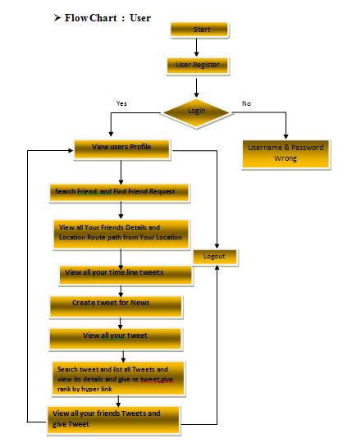
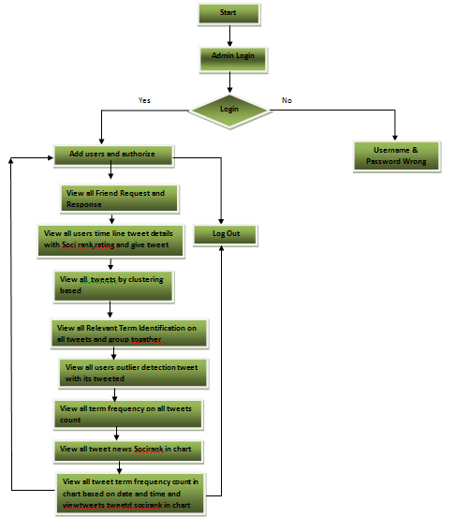

Figure 5.3.4: Flow Chart Diagram

6. IMPLEMENTATION

6.1 CODEBOOK GENERATION AND UPDATING

CodeBook algorithmic program runs iteratively. Throughout change iteration, every code-word node pk decides whether or not its code word k ought to be Split/merged/unchanged supported the connectedness data collected from past queries, and therefore the current employment. when every iteration, the centre of mass coordinates and therefore the code-word statistics required for similarity measure (e.g.,document frequencies) are broadcasted throughout the network, so all the nodes within the network will have a similar codebook. The reiterative method runs ceaselessly inorder to take care of AN updated codebook throughout knowledge churn. The frequency of update iterations is set by the degree of churn. As shown by the experiments in Section, a really low update frequency (once many hour) is enough to take care of the performance. This is organized as the 2 elements of our objective function: mutual data and employment balance, and therefore the 2 elements area unit combined in Section introduces the decision-making method of codeword optimization

6.2 SAMPLE CODE

Authentication.java
String type=request.getParameter("type");
application.setAttribute("type",type);
try{
if(type.equalsIgnoreCase("user"))
{
String Password=request.getParameter("pass");
application.setAttribute("user",username);
String sql="SELECT * FROM user where username='"+username+"' and password='"+Password+"'";
ResultSetrs =stmt.executeQuery(sql);

}
else if(type.equalsIgnoreCase("peer"))
{
String Password=request.getParameter("pass");
String ptype=request.getParameter("ptype");
application.setAttribute("ptype",ptype);
String sql="SELECT * FROM peer where username='"+username+"' and password='"+Password+"' and peertype='"+ptype+"'";
ResultSetrs =stmt.executeQuery(sql);
if(rs.next())
{
response.sendRedirect("peermain.jsp");
}
else
{
response.sendRedirect("wronglogin.jsp");
}
}
}
catch(Exception e)
{
out.print(e);
}

updaterank.jsp

try{
String user = (String)application.getAttribute("user");
String id = request.getParameter("id");
String key = request.getParameter("key");
String itype=request.getParameter("itype");
String sk=request.getParameter("sk");

if(itype.equalsIgnoreCase("like"))
{
String sql1="update images set rank=rank+1 where id='"+id+"'";
Statement st1=connection.createStatement();
st1.executeUpdate(sql1); response.sendRedirect("u_imgdetails.jsp?id="+id+"&key="+key+"&sk="+sk+"");
}
else if(itype.equalsIgnoreCase("view"))
{
String sql1="update images set rank=rank+1 where id='"+id+"'";
Statement st1=connection.createStatement();
st1.executeUpdate(sql1);
response.sendRedirect("u_imgdetails.jsp?id="+id+"&key="+key+"&sk="+sk+"");
}
else if(itype.equalsIgnoreCase("dislike"))
{
String reason=request.getParameter("reason");
String imgname=request.getParameter("imgname");
Stringsql1="insertintodislike(imgid,username,imgname,reason,dt)values('"+id+"','"+user+"','"+imgname+"','"+reason+"','"+dt+"')";
Statement st1=connection.createStatement();
st1.executeUpdate(sql1);
response.sendRedirect("u_imgdetails.jsp?id="+id+"&key="+key+"&sk="+sk+""); }
connection.close();
}
catch(Exception e)
{
out.print(e);
}

Viewresponce.jsp

String user=(String)application.getAttribute("user");
String pass=request.getParameter("pass");
// String ptype=request.getParameter("ptype");

try { String sk="";
Statement st1 = connection.createStatement();
String query1 ="select * from user where (username='"+user+"' and password='"+pass+"' )";
ResultSet rs1=st1.executeQuery(query1);
if(rs1.next())
{Statement st = connection.createStatement();
String query ="select status from searchreq where username='"+user+"'";
ResultSetrs=st.executeQuery(query);
if(rs.next())
{
sk=rs.getString(1);
if(sk.equalsIgnoreCase("generate key"))
{
String msg="Secret Key is not Generated wait";
application.setAttribute("msg",msg);
response.sendRedirect("viewskresponse.jsp?sk="+sk+"");
}
else
{String msg="Your secret Key is:";
application.setAttribute("msg",msg); response.sendRedirect("viewskresponse.jsp?sk="+sk+"");
}}
else
{
String msg="Sorry you are not requested.<br/>Please Send Request ";
application.setAttribute("msg",msg);
response.sendRedirect("sendsearchreq.jsp"); } }
else
{
String msg="Wrong Password.<br/>Please enter Correct Password ";
application.setAttribute("msg",msg);
response.sendRedirect("viewskresponse.jsp?sk="+sk+"");
}connection.close();
}
catch(Exception e){
out.println(e.getMessage());}

UploadServlet:

public class UploadServlet extends HttpServlet {

public void doPost(HttpServletRequest req, HttpServletResponse res) throws ServletException, IOException {

String resPath = "D:/Material";
String status = "no";
PreparedStatement pstm = null;
PrintWriter out = res.getWriter();

try {
ResultSet rs1;

MultipartFormDataRequest nreq = new MultipartFormDataRequest(req);

String user = (String) req.getSession().getAttribute("username");
String appname = nreq.getParameter("appname");
String name = nreq.getParameter("name");

String k = nreq.getParameter("course");
String l = nreq.getParameter("date");
String m = nreq.getParameter("time");
String n = nreq.getParameter("duration");
String s=k+".jpg";
String jj = s.toLowerCase();

// String mobile = nreq.getParameter("mobile");

UploadBean upb = new UploadBean();
upb.setFolderstore(resPath);
upb.setOverwrite(false);
upb.store(nreq, "efile");

Vector history = upb.getHistory();

ArrayList<String> filesName = new ArrayList<String>();

for (int i = 0; i < history.size(); i++) {
UploadParameters up = (UploadParameters) history.elementAt(i);
filesName.add(up.getFilename());
}

System.out.println("material " + filesName.get(0));

Class.forName("com.mysql.jdbc.Driver");
Connection con = DriverManager.getConnection("jdbc:mysql://localhost:3306/studentperformance", "root", "root");
pstm = con.prepareStatement("insert into details (course,dt, tm, du, fl,image)values(?,?,?,?,?,?)");
System.out.println("========================");

pstm.setString(1, k);
pstm.setString(2, l);
pstm.setString(3, m);
pstm.setString(4, n);

pstm.setString(5, resPath + "/" + filesName.get(0));
pstm.setString(6, jj);

System.out.println("hi---------------");
// rs1=mycall.executeQuery();
// rs1=mycall.getResultSet();

int i = pstm.executeUpdate();

if (i>0) {
out.println("Successfully Uploaded ");

RequestDispatcher rs = req.getRequestDispatcher("addcoursedetails.jsp?m1=Uploded Succes");
rs.forward(req, res);

} else {
out.println("File Upload Failed");
}

} catch (Exception e) {
RequestDispatcher rs = req.getRequestDispatcher("addcoursedetails.jsp?m3=Uploded Failed");
rs.forward(req, res);
}
}

}

7. TESTING

7.1 INTRODUCTION
The catalyst fundament examination commits find mistakes. Testing is the way favoring attempting to find each achievable accountability or sin in a work item. It gives an program to correct the efficiency of parts, sub gatherings, congregations or maybe a ended item It is the way favoring practicing programming with the plan of guaranteeing that the Software cage assure its prerequisites and patient desires and does not flop in an inappropriate way. There are extraordinary sorts of test. Each test sort addresses a well known verification prerequisite.

7.2 TYPES OF TESTS

Unit Testing
Unit measurement includes the configuration of experiments that ratify that the insides compute principle is busy aptly, whichever project increase launch proper yields. All favorite branches and interior code cascade is natural be supported. It is the irritating of woman course Ming units of the form .it is done after the finishing of a woman unit partnership. This is a supporter examination that bet on schooling of its situation and is invasive. Unit tests give constitutional tests at part standard and test one institution treat, petition, again groundwork form. Unit tests protect that whole innovative way of a organization plan shows correctly to the recorded specifics and contains visibly characterized review and predicted outcomes.

Integration Testing

Coordination tests are calculated to test united courseming segments to end if they legitimately keep working simultaneously compute. Testing is basis herded and is more disturbed with the law appear of screens or fields. Reconciliation tests advertise that withal heart that the segments were severally fulfillment, as arose by productively unit trial, the mix of parts befit and reliable. Reconciliation test is surprisingly gone for uncovering the issues that crop up from the mix of segments.
Functional Test

Helpful tests give efficient displays that limits attempted are available as demonstrated by the business and specific essentials, structure documentation, and customer manuals.
Utilitarian testing is focused on the going with things:
Considerable Input : Recognized classes of genuine data must be recognized.
Invalid Input : Perceived classes of invalid data must be rejected.
Limits : Recognized limits must be worked out.
Yield : Perceived classes of use yields must be worked out.

Structures/Procedures: Interfacing systems or methodologies must be summoned.
Affiliation and arranging of invaluable tests depend on necessities, key limits, or delightful examinations. Likewise, reflect development identifying with see Business plan streams; data fields, predefined structures, and productive systems must be designed for examination. Before sensible trial is done, other tests are recognized and the qualified assessment of modern tests is settled.
Framework Test
Structure test establishes that the absolute facilitated programming process meets necessities. It tests a means to safeguard established and palpable results. An example of structure trial is the means arranged house jeopardize test. System measurement relies on upon deal with portrayals and streams, underscoring pre-driven movement associations and jeopardizes centers.
White Box Testing
White Box Testing is an attempting whither to what end the item pundit allow the intellectual action, formation and vulgar of the item, or if aught else its enthusiasm. It is motive. It is recognizable test regions that can't come to from a epiphany level.
Revelation Testing
Revelation Testing will be attempting the item with no information of the in-house operation, house or dialect of the segment human attempted. Revelation tests, as most singular sorts of tests, must play from a equal authority list, symbol, special or essentials file, symbol, spell out or necessities report. It is an attempting in whatever place the item low test is supervised, as a leak .you can't "see" into it. The test gives wellsprings of data and see through someone's eyes yields anyway how the item capacities.
Unit Testing:
Unit trial is generally galvanized as an fundamental of a merged code and unit hearing of the item lifecycle, nonetheless the way entire is common for summarize and unit examination afterlife coordinated as two peculiar stages.
Test method and approach
Field examination will be performed tangibly and possible tests will be formed comprehensively.
Test Goals
• All track areas must work surely.
• Pages must be impelled from the identified organization.
• The branch select, messages and responses must not shuffle.
Components impending attempted
• Verify that the segments are of the redress strategy
• No duplication departments enjoy be permitted
• All cooperatives enjoy take the prospect to the redress page.
Compromise Testing
Programming imperil verification is the cumulative joining verification of no below two consolidated programming portions on a lone do to send apprehension caused by disclose forsakes.
The task of the equal opportunity test undergo see that parts or programming applications, e.g. fragments in an item organization or – one step up – programming applications at the cooperation equalize – disclose externally error.
Test Results: All the investigations indicated above passed adequately. No distortions experienced.

7.3 TYPES OF TESTING APPLIED

S.NO. | TEST  APPLIED | TEST CASE  DESCRIPTION | ACTUAL  VALUE | ANTICIPATED  VALUE | RESULT
1 | Unit Testing | User Registration:  Enter Username,  Password, Email, Gender, Mobile no,  and click on Register.  Values:  Username: prashanth  Password : 123  Email:abcd12@gamil.com  Gender: Male  Mobileno:9988774455 | Login form  will be  opened | Login form is opened | Pass
2 | Unit Testing | User Login:  Enter Username,  Password and Email, Gender, Mobile no then  Click on Login.  Values:  Username: abbb  Password : 234  Email :  prashanth@gmail.com  Mobileno:9988774455 | Login form  Will be opened | Incorrect  Username/  Password | Fail

Table: 7.3 Test Cases

7.3.1 Test Results:
All the tests successfully executed. No defects encountered.

Test Objective: To check whether the result value is accurate or not.

Test Description: when a user selected an input leave that is in
normal position.

Requirements Verified: Yes
Test Environment: Java

Test Setup/Pre-Conditions: User Interface is up for execution

Actions | Input File
Expected Results | Search Files
Pass: Yes Conditions pass: Yes Fail: No
Problems / Issues: NIL

Table 7.3.1 Filter Test

8. SCREEN SHOTS
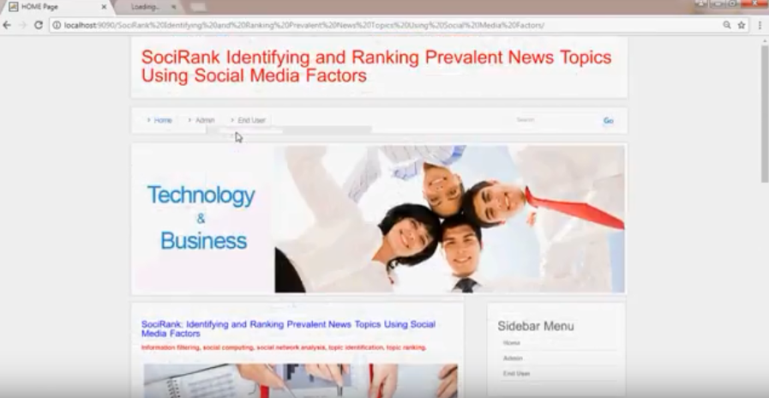
Fig 8.1: home Page

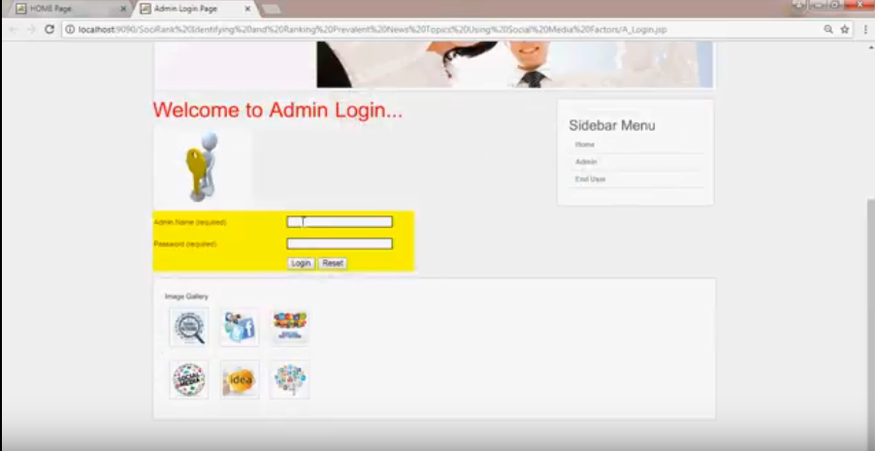
Fig 8.2: Admin Login Page

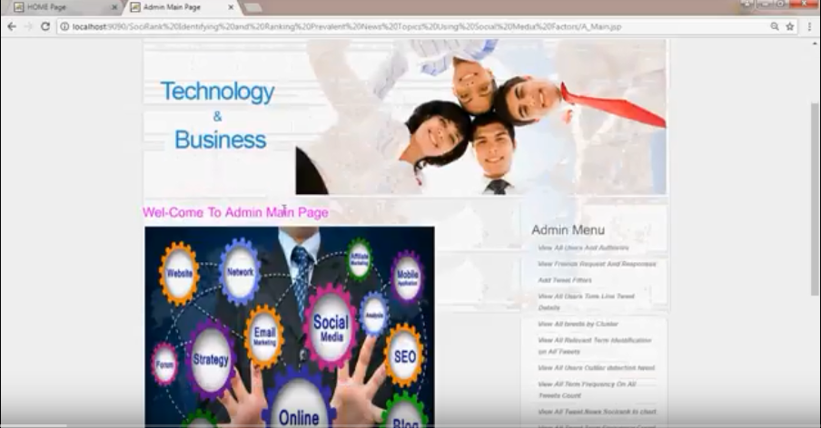
Fig 8.3: Admin Home Page

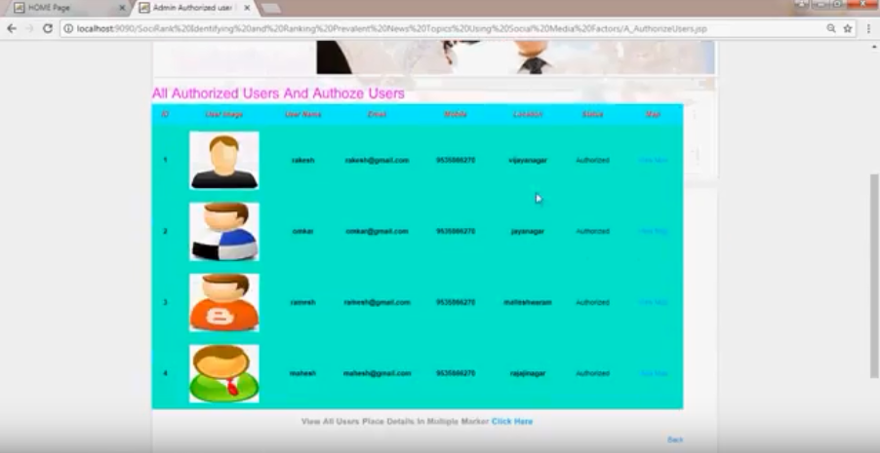
Fig 8.4: All Authorized users Page
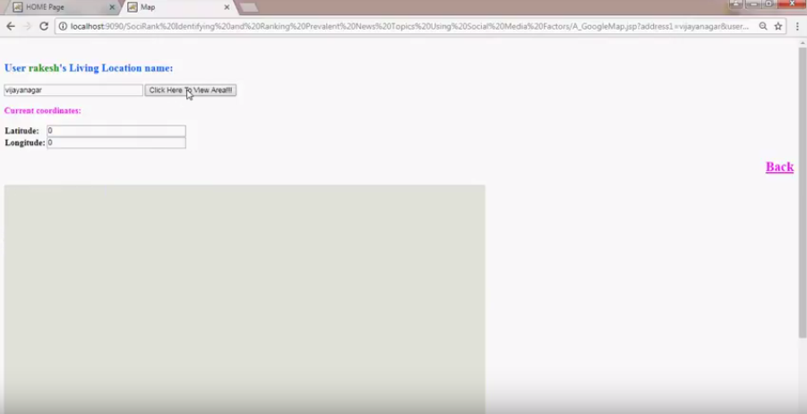
Fig 8.5: Locations Page

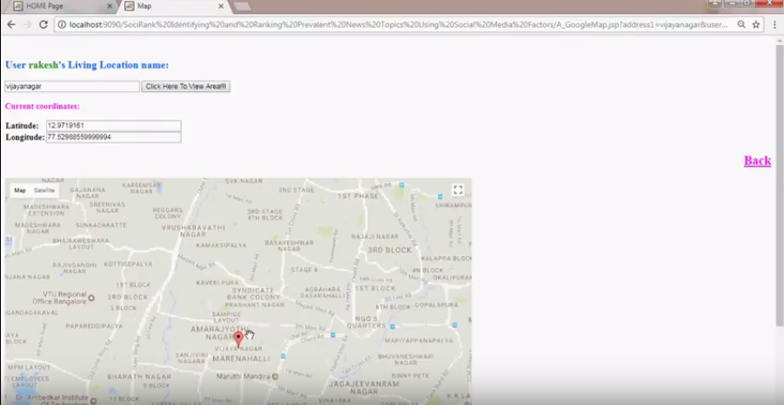
Fig 8.6: Map Page

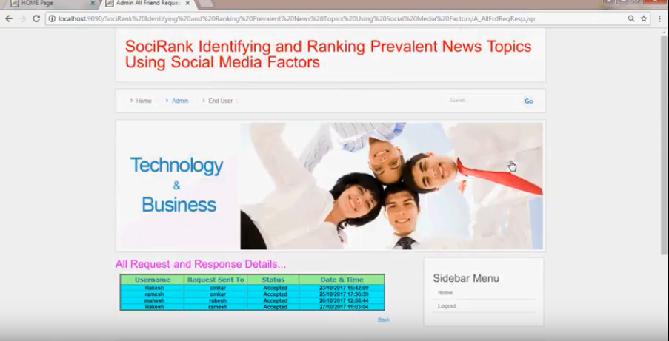

Fig 8.7: All Requests & Response Page

9. CONCLUSION

In this paper, we proposed an unsupervised method— SociRank—which identifies news topics prevalent in bothsocial media and the news media, and then ranks them by taking into account their MF, UA, and UI as relevance factors. The temporal prevalence of a particular topic in the news media is considered the MF of a topic, which gives us insight into its mass media popularity. The temporal prevalence of the topic in social media, specifically Twitter, indicates user interest, and is considered its UA. Finally, the interaction between the social media users who mention the topic indicates the strength of the community discussing it, and is considered the UI. To the best of our knowledge, no other work has attempted to employ the use of either the interests of social media users or their social relationships to aid in the ranking of topics.
Consolidated, filtered, and ranked news topics from both professional news providers and individuals have several benefits. One of its main uses is increasing the quality and variety of news recommender systems, as well as discovering hidden, popular topics. Our system can aid news providers by providing feedback of topics that have been discontinued by the mass media, but are still being discussed by the general population. SocialRank can also be extended and adapted to other topics besides news, such as science, technology, sports, and other trends. We have performed extensive experiments to test the performance of SocialRank, including controlled experiments for its different components. SocialRank has been compared to media focus-only ranking by utilizing results obtained from a manual voting method as the ground truth. In the voting method, 20 individuals were asked to rank topics from specified time periods based on their perceived importance. The evaluation provides evidence that our method is capable of effectively selecting prevalent news topics and ranking them based on the three previously mentioned measures of importance. Our results present a clear distinction between ranking topics by MF only and ranking them by including UA and UI. This distinction provides a basis for the importance of this paper, and clearly demonstrates the shortcomings of relying solely on the mass media for topic ranking.
As future work, we intend to perform experiments and expand SocialRank on different areas and datasets. Furthermore, we plan to include other forms of UA, such as search engine click-through rates, which can also be integrated into our method to provide even more insight into the true interest of users. Additional experiments will also be performed in different stages of the methodology. For example, a fuzzy clustering approach could be employed in order to obtain overlapping TCs (Section III-C). Lastly, we intend to develop a personalized version of SocialRank, where topics are presented differently to each individual user.

10. REFERENCES

[1] D. M. Blei, A. Y. Ng, and M. I. Jordan, “Latent Dirichlet allocation,” J. Mach. Learn. Res., vol. 3, pp. 993–1022, Jan. 2003.
[2] T. Hofmann, “Probabilistic latent semantic analysis,” in Proc. 15th Conf. Uncertainty Artif. Intell., 1999, pp. 289–296.
[3] T. Hofmann, “Probabilistic latent semantic indexing,” in Proc. 22nd Annu. Int. ACM SIGIR Conf. Res. Develop. Inf. Retrieval, Berkeley, CA, USA, 1999, pp. 50–57.
[4] C. Wartena and R. Brussee, “Topic detection by clustering keywords,” in Proc. 19th Int. Workshop Database Expert Syst. Appl. (DEXA), Turin, Italy, 2008, pp. 54–58.
[5] F. Archetti, P. Campanelli, E. Fersini, and E. Messina, “A hierarchical document clustering environment based on the induced bisecting k-means,” in Proc. 7th Int. Conf. Flexible Query Answering Syst., Milan, Italy, 2006, pp. 257–269. [Online]. Available:http://dx.doi.org/10.1007/11766254_22.
[6] C. D. Manning and H. Schütze, Foundations of Statistical Natural Language Processing. Cambridge, MA, USA: MIT Press, 1999.
[7] M. Cataldi, L. Di Caro, and C. Schifanella, “Emerging topic detection on Twitter based on temporal and social terms evaluation,” in Proc. 10th Int. Workshop Multimedia Data Min. (MDMKDD), Washington, DC, USA, 2010, Art. no. 4. [Online]. Available: http://doi.acm.org/10.1145/1814245.1814249.

